The AI execution gap in B2B marketing
AI optimism surges while organizational action stalls

AI overview

Here … let me do it for you
B2B marketing leaders overwhelmingly embrace AI personally. 82% use it daily and 56% call it transformational. Yet their companies lag dramatically behind. This research of 300+ marketing leaders reveals a critical execution gap—while marketers believe AI requires substantial investment across core B2B marketing functions such as content strategy, analytics, and team productivity, actual organizational investment stands at only one-quarter of perceived needs, a 46-point shortfall.

The consequences are measurable: high-performing companies invest 42% more in AI and credit it for over 80% of performance gains, while the majority report flat or declining results.
Private equity-backed firms face the starkest paradox—92% of their marketers use AI daily (highest among all funding types), yet their organizations invest 30% less than competitors, resulting in only 25% achieving high performance. Individual conviction has raced ahead of organizational action, and the cost of inertia is rising as early adopters accelerate away from the pack.

WOULD YOU LIKE ME TO GET BACK TO PLANNING YOUR DISNEY VACATION, OR SHOULD WE KEEP WORKING ON THIS REPORT?

Human overview

Not just for executives anymore

B2B marketing leaders are embracing AI personally, but their organizations are still holding back
This report synthesizes insights gathered from more than 300 marketing leaders from B2B technology companies during a two-week period in October 2025, a sample 3-4x larger than other research we performed this year (and with far less participant recruitment). Turns out marketers are very eager to talk about AI—especially when they're trying to convince their bosses to actually fund it. Participation at this scale signals the urgency marketers feel about AI adoption and their fear of falling behind.
In our survey and in follow-up questions and subsequent interviews, B2B tech marketers expressed their (justifiable) worries that their companies are falling behind when it comes to AI adoption. And they are actively searching for credible information to support or defuse their growing FOMO.
Unfortunately, this survey on AI adoption in B2B marketing reveals a widening divide. Companies that are implementing AI strategies in earnest are far ahead of their peers and already reaping significant benefits. For the majority of marketing leaders in B2B tech companies, it should become clear in reading this report that AI adoption is no longer a speculative gambit or philosophical question. Rather, it’s a business imperative. And for marketing leaders, AI signals a critical inflection point (both personally and professionally).
The data reveal a profound contradiction that demands the attention of every B2B tech executive: marketing leaders overwhelmingly believe that AI will transform B2B marketing (especially in areas like content strategy, analytics and reporting, outbound marketing, sales enablement, and team productivity). Unfortunately, their employers are largely ill-prepared to implement AI in marketing, and have been slow to invest in areas where marketing executives believe AI can have the most significant and immediate impact on business outcomes.
- Marketers: 82% use AI daily, 80% feel confident in the tools, 59% believe it will have a significant or major impact on marketing and 56% say it’s transformational
- Companies: 96% lack a dedicated AI role, 86% report no major investment, 78% aren’t ready

The gap is measurable
Organizational investment stands at roughly one-quarter of what marketers believe is required. That’s a 46-point shortfall. And performance is splitting along that fault line: 35% of companies report better marketing results than in 2022, 49% are flat, and 16% are worse. The outperforming cohort shows higher AI readiness (3.25 vs. 2.76 on a five-point scale) and overwhelmingly credits AI for more than 80% of its performance gains.
This is not a knowledge problem. B2B marketing leaders are among the most active business users of AI, with widespread familiarity and experimentation across tools and functions. Most rely on general-purpose platforms:
- 84% use ChatGPT
- 36% use Gemini
- 29% use Claude

By contrast, fewer than 2% report using purpose-built AI tools such as Jasper, HeyGen, or Clay, and virtually none are using AI-native marketing platforms like Creatio that could replace systems like HubSpot or Salesforce. This proves, once again, that we all prefer the cheap option when our employers won't pay for the good stuff.
As in every disruptive technology cycle, understanding has raced ahead of execution. Individual conviction now outpaces organizational will. The cost of that inertia is rising. High-performing companies invest 42% more in AI and are accelerating away from the pack. The gap is widest among private equity-backed firms, which exhibit the most advanced individual adoption but the lowest organizational readiness compared with their publicly traded, venture-backed, and revenue-funded peers.

Private equity-backed companies fall further behind
Private equity-backed B2B technology firms show the widest AI execution gap. Their marketing leaders are among the most advanced personal users of AI, building custom GPTs, automating outreach, and integrating AI into campaign workflows. Yet their organizations lag in readiness, investment, and structure.
Not a single respondent from a private equity-backed company reported a dedicated AI budget, role, or team. Most described AI initiatives as informal and under-resourced, citing limited talent, time, and leadership guidance. Many expressed frustration with the absence of standards, training, and measurable outcomes. These are all signs of a system still in exploration mode while peers move to operationalize AI.
By contrast, revenue-funded, venture-backed, and publicly traded companies report higher readiness, clearer ownership, and greater support for AI initiatives. The conclusion is unavoidable: private equity-backed firms have the strongest believers in AI, but the weakest foundations to act on it. (We have included a special section about PE-backed companies in the appendix.)

AI adoption in B2B marketing has entered its decisive phase. The leaders who bridge this execution gap first will define the competitive landscape of the next decade.


The AI execution gap

Little improvement in core B2B marketing tactics since 2022
We asked marketing leaders to rate the current performance of their core B2B marketing tactics compared with three years ago on a five-point scale (from way worse to way better). The results draw a clear fault line.

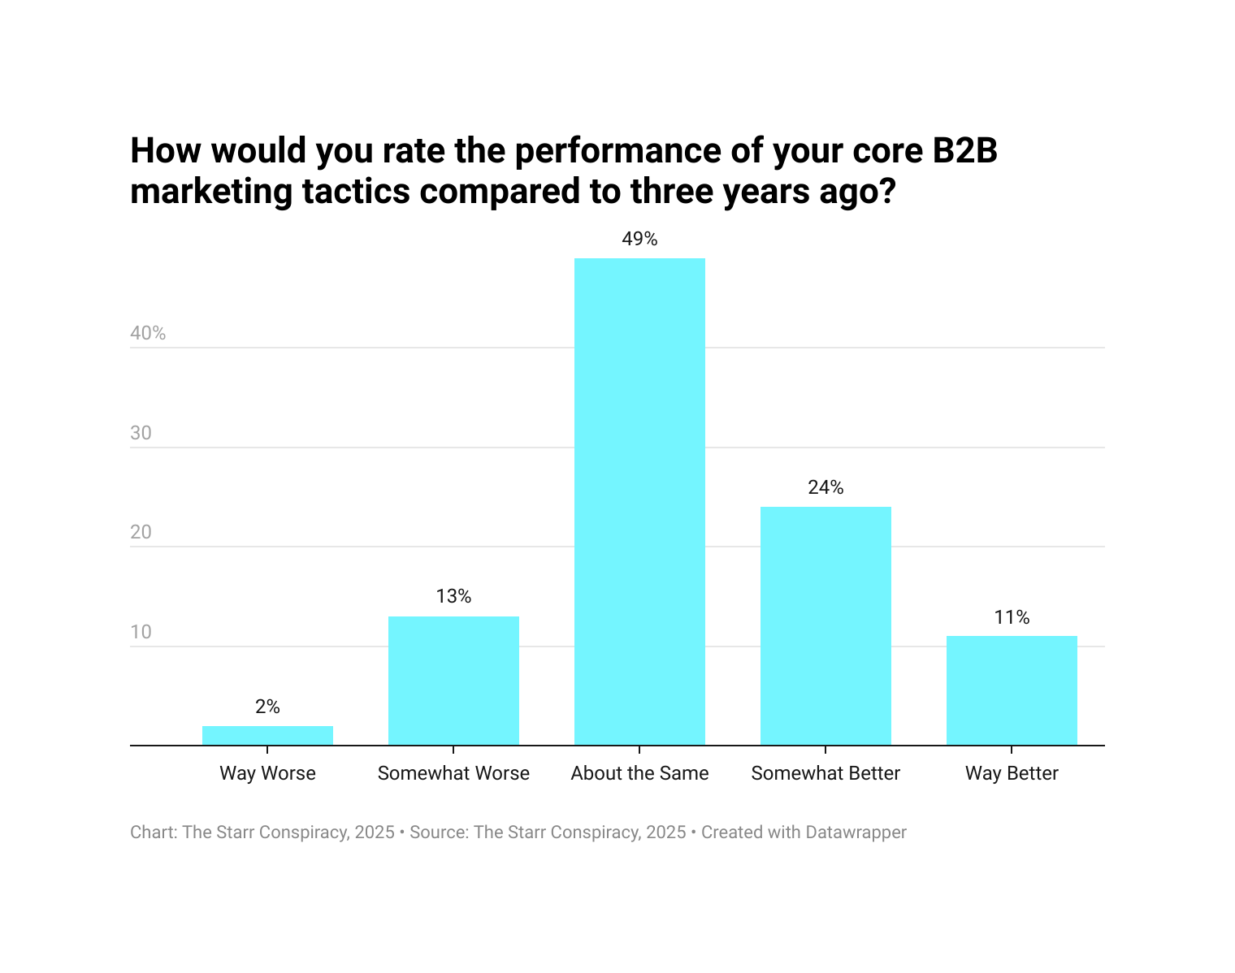

Nearly half (49%) say results are about the same. That’s a bitter pill for a discipline built on performance optimization. Additional context makes it sting even more: three years ago already represented a post-2021 performance trough for B2B tech marketing.

Meanwhile, 15% report
worse performance.
There is, however, a bright side (or a warning, depending on where you stand). Roughly 35% of marketers say performance has improved: 24% somewhat better, 11% way better. These aren’t outliers. They represent more than a third of the market. What’s emerging is a bifurcation—a high-performing minority breaking away from a stagnant majority.
Marketing leaders don’t strive for about the same performance. No one gets a bonus for about the same. Way better buys beach houses and sends kids to their first-choice college. The last twenty years in B2B marketing have been (almost exclusively) about performance optimization. Yet half of respondents are treading water at 2022 performance levels (and 15% are slipping under). The divide between the advancing minority and the struggling majority is widening fast.

AI adoption drives performance
Across our research, a clear and consistent pattern emerges: higher AI readiness correlates with stronger marketing performance. Companies that report somewhat better or way better results than three years ago also report an average AI readiness score of 3.25 (on a five-point scale), compared with 2.76 among those performing about the same or worse.
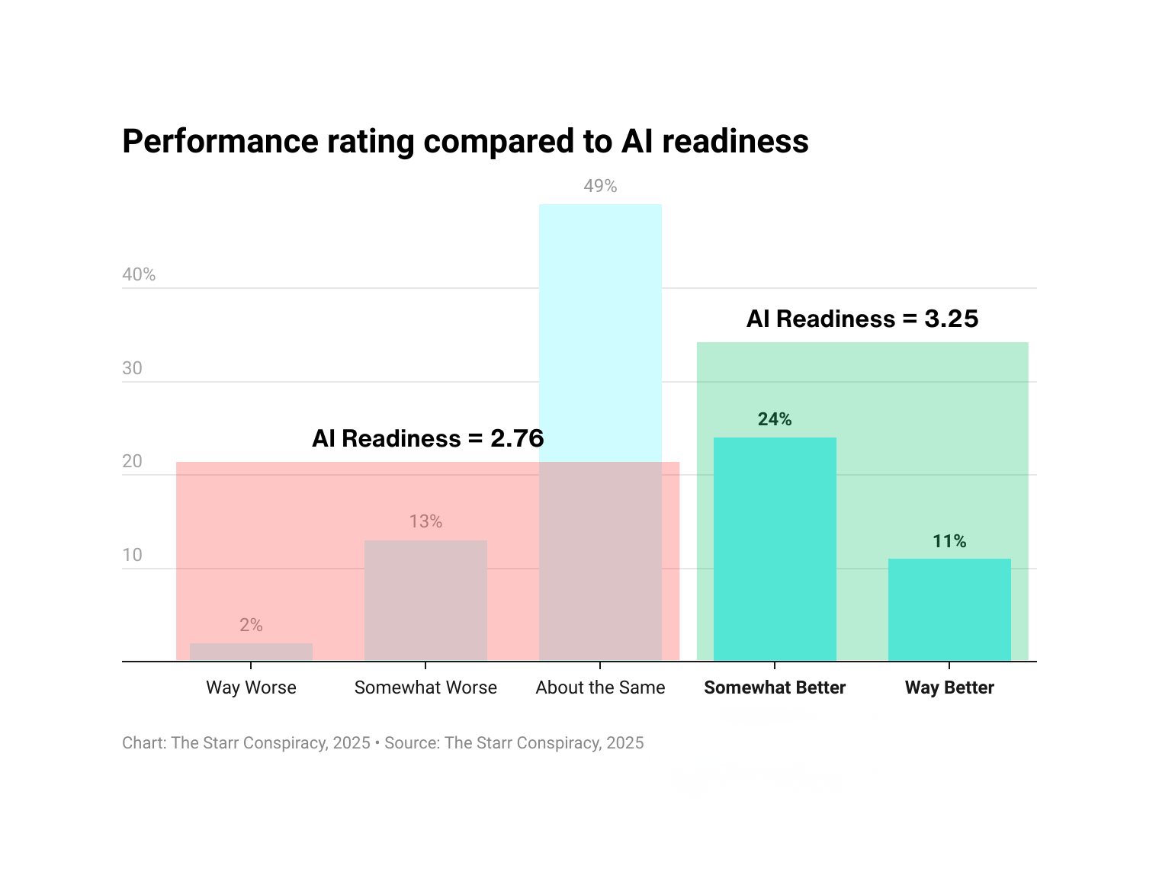

This isn’t a cherry-picked correlation. In follow-up interviews, marketing leaders repeatedly cited AI adoption as the dominant driver of improvement. Conversely, teams that have not adopted AI broadly attribute their stagnation or decline to exactly that absence.

Among the better-performing cohort, 94% specifically identified AI as the primary reason for their gains—far ahead of any other factor. The next most common drivers, such as data-driven decision making (31%), process improvements (23%), and leadership changes (15%), trailed by a wide margin. Many respondents even credited AI for enabling those other improvements, suggesting its impact is understated in direct attribution.
Marketers pointed to AI’s measurable contributions in several areas, including content acceleration (from landing pages to ad copy), data analysis, experimentation at scale, and conversion optimization. One leader summed it up: “AI hasn’t just sped up content—it’s multiplied what we can test and learn.”
The pattern is unmistakable: high-performing marketing organizations aren’t just dabbling in AI. They are systematically and cross-functionally operationalizing it, and putting real budget behind it. Their peers who haven’t yet made that shift are now visibly falling behind.

Stuck marketers reveal half-hearted organizational responses to AI disruption
The feedback from underperforming marketing organizations reveals a troubling pattern: while high performers leverage AI proactively to transform workflows and drive measurable results, struggling marketers are forced to avoid AI adoption entirely or deploy it reactively as a band-aid for declining legacy tactics. The contrast illuminates not just a technology gap, but a fundamental difference in strategic orientation.

Laggards are watching the ground shift
Among marketing leaders reporting worse performance than three years ago, the dominant narrative centers on organic traffic collapse. Half explicitly cite catastrophic SEO declines—one reporting web traffic falling to "approximately one-third of its volume from two years ago," directly impacting their ability to generate sales-ready leads. Another describes struggling with "constant changes in strategy and dropping web traffic due to answer engines," noting their SEO efforts can't gain traction because "no one is using Google anymore."
Most critically, 67% of declining performers either aren't using AI or have only begun experimenting with it due to organizational constraints. When AI appears in their responses, it's deployed individually, tactically, and reactively. These marketers "use my own ChatGPT to tweak content because my company doesn’t pay for it.” Or they are “recycling content with AI to save time,” or passively "hoping it will be effective." One participant mentions "considering exploring AI applications for marketing in 2026, specifically in content generation and personalization" … describing as future exploration what high performers identify as their current competitive advantage.
Their planned marketing responses to declining performance reveal conventional tactical pivots rather than strategic transformation: “exploring outbound, events, and direct mail as alternatives”; adopting "more targeted marketing with less wasteful spending"; or pursuing “advisor-led introductions”. These are routine maintenance activities conducted by companies that haven't come to terms with the fact that their performance optimization-based marketing machines are broken and can’t be fixed. It’s like banging on your old radiator instead of installing central heat. As their organic channels collapse under algorithmic disruption (e.g., AEO, AI overviews, search evolution), they're diversifying tactics without addressing the fundamental capability gap that AI creates.

The stagnant majority is trapped in shallow adoption
The about the same cohort, nearly half the sample, presents a more nuanced but equally concerning picture. While 42% report some AI usage, the application remains superficial and disconnected from strategic outcomes. They describe using "paid versions of ChatGPT and Gemini" for content creation support, or leveraging AI "for behind-the-scenes work, research, and task assistance."
Notably absent from stagnant performers' feedback? Any mention of AI-driven experimentation at scale, conversion optimization, or measurable performance improvements. One participant candidly acknowledged "several false starts implementing AI anything due to resource constraints and a lack of company support.”
In fact, resource constraints dominate their explanations for stagnation. Twenty-six percent cite insufficient budget, headcount, or time as barriers, while 16% describe organizational friction including founder resistance to experimentation, internal conflicts causing delays, or companies adopting a "wait-and-see approach" due to market uncertainty. One frustrated marketer noted that "performance has remained steady despite significant effort," blaming the founder's "fear" and resistance to "experiment or implement basic strategies."
The most revealing pattern among stagnant performers? They continue optimizing legacy playbooks while acknowledging those playbooks no longer work. Multiple participants described steady inbound leads "keeping their pipeline full" while simultaneously noting they haven't "experienced the expected growth from these leads" or struggle to "convert qualified leads into sales due to the declining quality of inbound leads." They're maintaining 2022 performance levels using 2022 tactics, obviously aware that the ground beneath them has fundamentally shifted, but with no organizational support to implement the necessary transformations.

The strategic chasm
The contrast with high performers couldn't be starker. High performers describe AI enabling "faster insights about what converts" and report "increased conversions compared to non-AI-augmented copy and processes.” Their responses and follow-up comments demonstrate closed-loop measurement and continuous optimization. Low and stagnant performers describe resource constraints, organizational barriers, and external market conditions, attributing their struggles to organizational circumstances while emphasizing that their personal vision and capability outstrips that of their leaders and company in general.
This represents more than an innovation or adoption gap. This is a strategic chasm. Struggling organizations treat AI as a potential cost-saving tool for content production or a future consideration once resources improve. Meanwhile, high performers have fundamentally restructured their operations around AI-enabled experimentation, personalization, and optimization, thus widening a performance gap that resource-constrained competitors cannot close through incremental improvements to legacy tactics.
The implications are unambiguous: organizations stuck in tactical thinking—whether declining or stagnant—face not just temporary underperformance but strategic obsolescence. Their Google-dependent models are collapsing under algorithmic disruption. Their resource constraints prevent the experimentation velocity that AI enables for competitors. Their organizational barriers and leadership friction prevent the cultural transformation required. They're watching their foundations erode while debating whether to invest in the basic tools their competitors have already turned into systematic advantages.

No marketing function is over-invested with AI innovation

Rating AI impact on twenty core marketing functions
The heart of our research is a comparison between the areas where marketing leaders believe AI can provide value and how funding is (or isn’t) applied to these areas. For this project, we evaluated the attitudes, behaviors, and beliefs related to twenty core B2B marketing functions. Below is a list of these functions ranked from highest perceived impact to lowest.
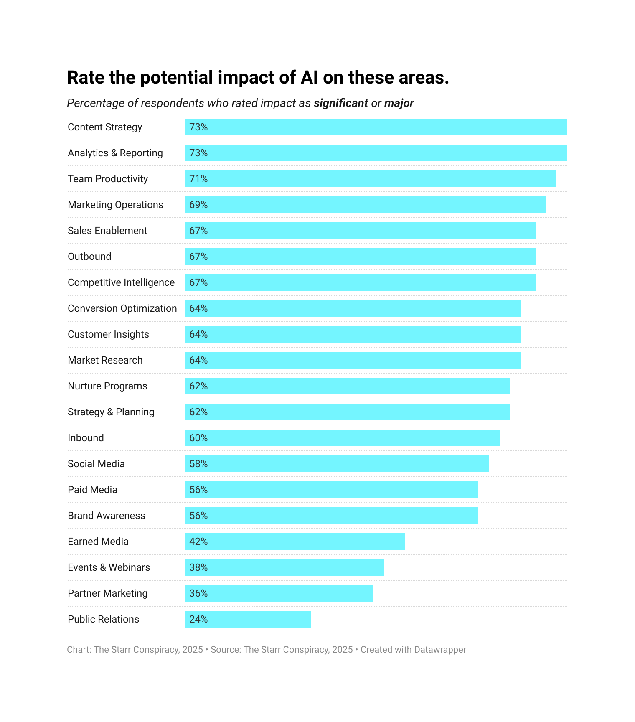


Is this the perfect list? Is it exhaustive?

Of course not.

But that wasn’t our goal. Rather, our aim was to simply report on the state of AI adoption in marketing across a broad and significant group of B2B tech companies. We used these twenty functions as a starting point for discourse and deeper understanding. And what we found surprised us in many ways, but not entirely.
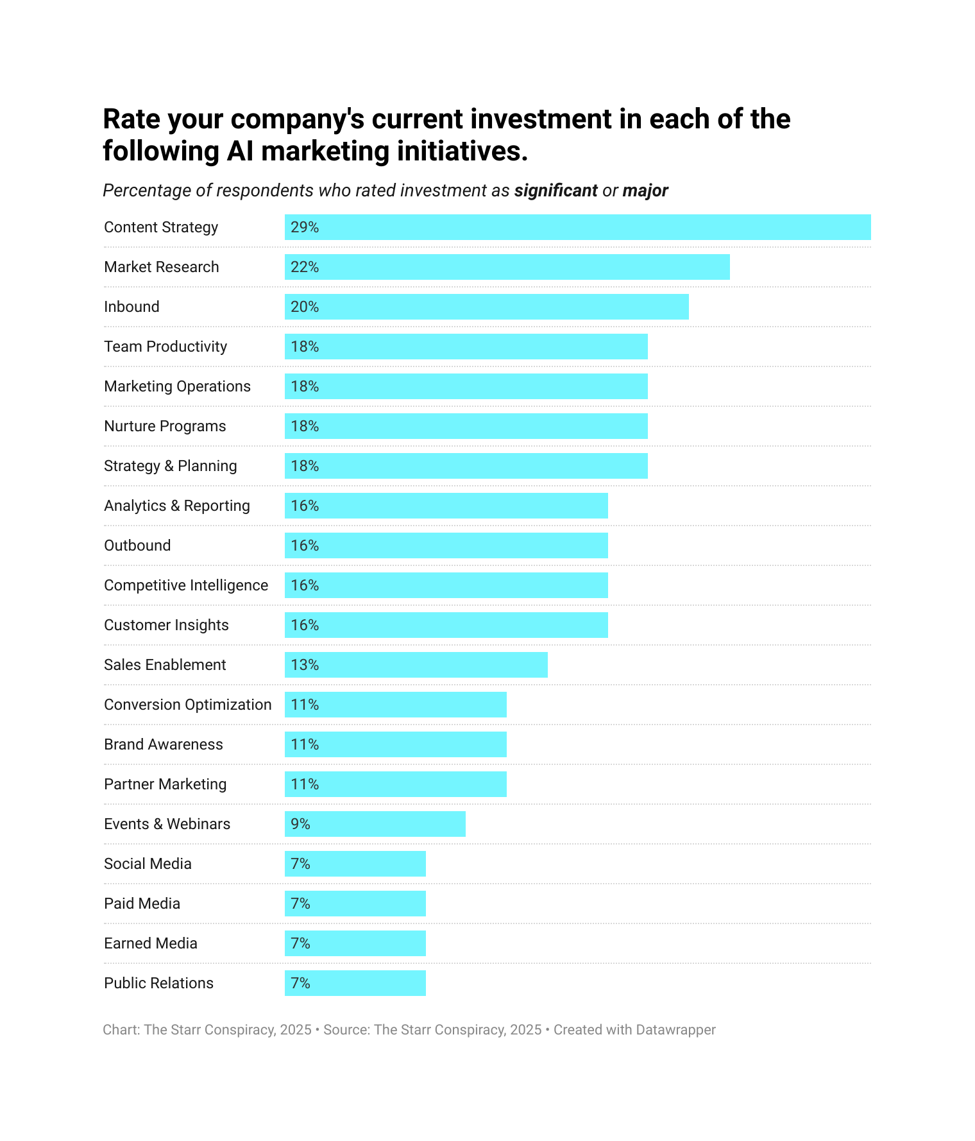

The chart above shows how unevenly companies are investing in AI across functional areas in B2B marketing. And it’s a tidy snapshot of the execution gap this report describes. Despite widespread belief in AI’s transformational potential, only a handful of marketing functions are seeing meaningful investment.
As we see above (and below in more detail), a minority of marketing leaders reported significant or major investments in:
- Content Strategy (29%)
- Market Research (22%)
- Inbound Marketing (20%)

And beyond the top three listed above, investment is even more sparse. For example, investments in functions that could be considered AI infrastructure hover around 18%:
- Team Productivity (18%)
- Marketing Operations (18%)
- Strategy & Planning (18%)

While other critical functions languish:
- Conversion Optimization (11%)
- Events & Webinars (9%) [This actually makes sense, since AI can't yet schmooze at cocktail hours or pretend to be interested in awkward booth conversations.]
- Paid Media (7%)

In short, companies are applying limited AI resources to insight gathering, idea generation and creative output, while leaving infrastructure, amplification and optimization virtually unfunded. The data reveal a landscape of bridled enthusiasm … marketers know where AI could transform outcomes, but their organizations are still dabbling, not deploying. And this, of course, is only a microcosm of the broader hesitation slowing AI’s full integration into B2B marketing.

AI impact vs. investment in marketing functions
A deeper analysis comparing marketers’ perception of AI’s potential impact and the level of significant/major investment in the same twenty key marketing functions reveals a consistent and significant gap. While expectations for AI’s transformational impact remain high, investment has not kept pace.
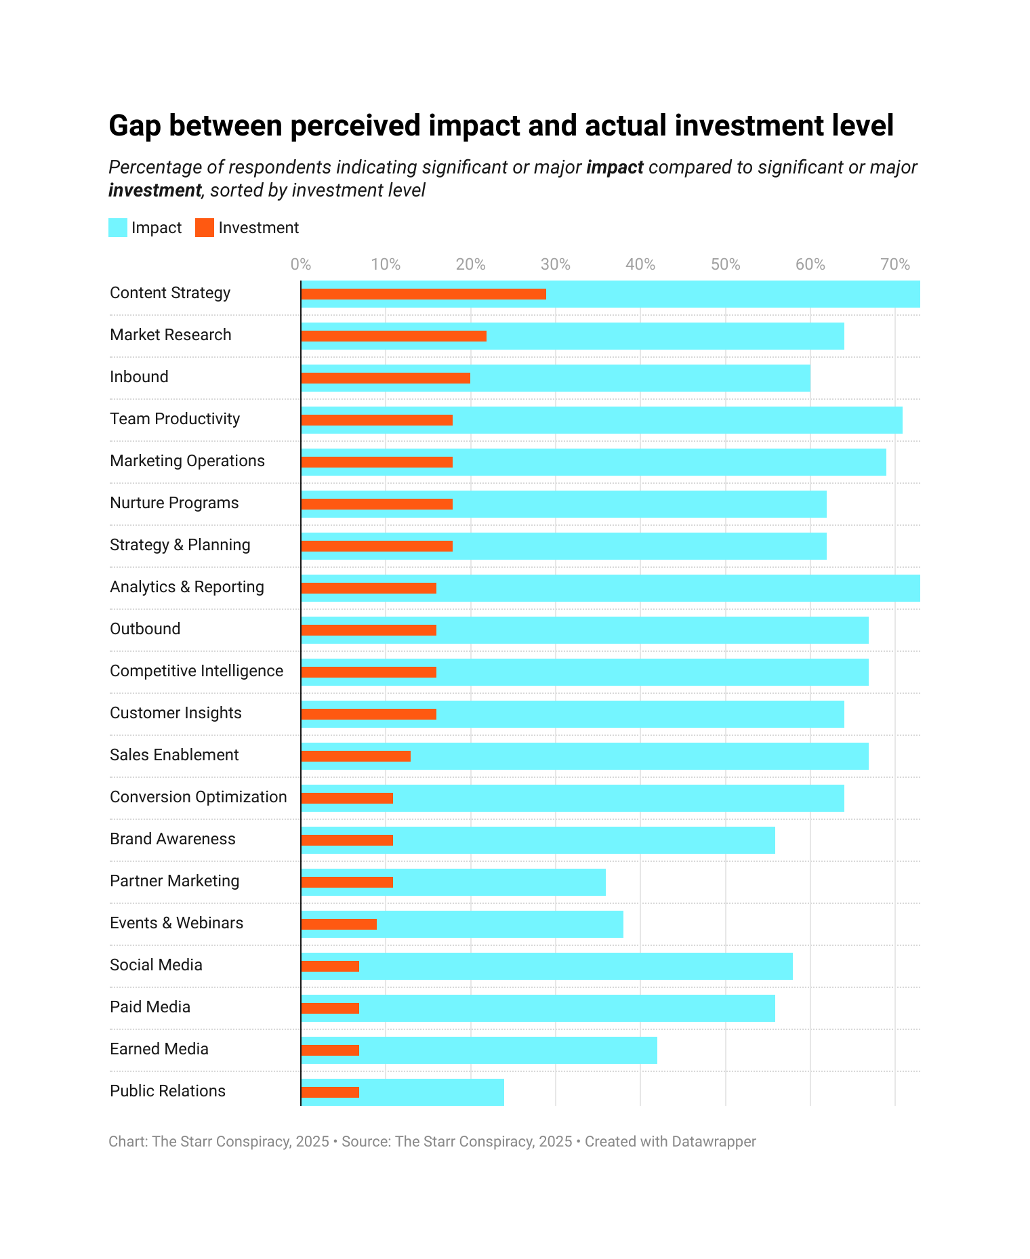


Marketers overwhelmingly anticipate AI will have a significant or major impact across content strategy, analytics, team productivity, operations, and sales enablement. In these domains, high expectations for AI-powered transformation routinely exceed 60–70%. However, investment levels lag behind by an average of nearly 46 points.
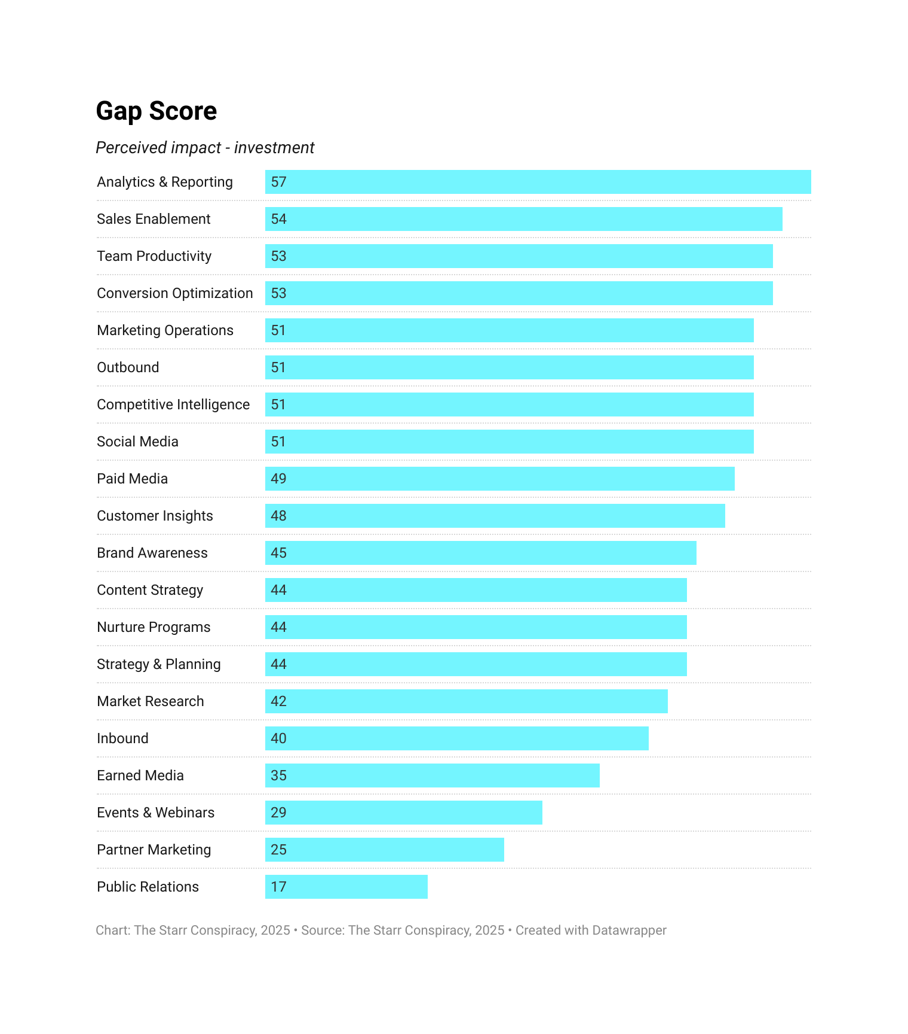
In high-impact domains like Content Strategy, Analytics, Team Productivity, and Operational areas, the gap is most pronounced—indicating organizations see AI’s promise but have not yet committed comparable financial or organizational resources to realize it.
This persistent gap highlights a classic pattern of technological adoption. Widespread recognition of disruptive potential precedes the establishment of robust implementation strategies and budget allocations. It suggests that while marketers are sold on the transformational case for AI, organizational inertia, budget pressures, and perhaps uncertainty around use cases or ROI are constraining actual investments.
The bad news: B2B tech companies face a critical inflection point. The reality is that marketing teams who recognize AI’s impact but underinvest in execution will lose competitive ground to more aggressive early adopters. Shifting from vision to concrete investment is essential to extract maximum business value from AI and close the execution deficit that could otherwise widen over time.
The good news: many marketing leaders we spoke with expect a massive reset of priorities during the 2026 budgeting process. In fact, many are finished with their budgeting process already, have dedicated funds for both people and programs in 2026 and are simply waiting for the new budgets to kick in.

How to AI in B2B marketing
These recommendations are not theoretical. The data shows exactly what separates leaders from laggards: structure, conviction, and focus. The recommendations below are designed for immediate deployment across all funding types. However, it’s important to consider the built-in advantage possessed by startups (bootstrapped and especially venture-backed). Private equity-backed, revenue-funded, and publicly traded companies will need to work much harder to adapt to AI trends due to the obstacles presented by existing infrastructure (both tech and process).

Appoint a dedicated AI marketing owner immediately
This is the most straightforward decision any marketing organization can make. With only 4% of companies assigning a dedicated AI marketing role, simply naming one person to own it becomes a competitive advantage. Most companies will need to appoint an existing internal resource (as opposed to hiring externally) because it’s nearly impossible to find experienced AI marketing talent (and, in many cases, cost prohibitive). And don’t make it part of their job. Make it their entire job.
Start by assigning a single point of responsibility to:
- Audit current AI usage and eliminate redundant tools
- Implement a foundational AI toolkit (e.g., ChatGPT for daily workflow, Perplexity for research assistance)
- Prioritize 3–5 high-impact AI use cases for marketing and sales (e.g., content generation, market research, cold outbound)
- Build AI literacy through internal showcases, demos, and short training sessions
- Own vendor evaluation, compliance review, and implementation roadmaps
You don’t need to hire a “Head of AI” to get started. (But that would be great! Keep in mind that the CIO role was created in response to the proliferation of unregulated SaaS solutions within companies.) Right now, you simply need someone whose job is working AI into everyone’s job!

Lead with AEO and AI content strategy
The fastest path to ROI is visibility, not automation.
As Google’s search ecosystem collapses under its own algorithmic weight, both organic and paid performance are eroding. Blue-link clicks are in free fall. Paid clicks are down. The old inbound playbook (write, rank, repeat) has stopped working. But inside that decay lies the opportunity of the decade: Answer Engine Optimization (AEO).
AEO represents the new frontier of inbound. Where traditional SEO chases traffic, AEO earns answers—placements inside AI overviews, synthesized responses, and conversational engines that are now shaping discovery. It’s early-stage terrain, which means there’s still daylight. Companies that deploy AI now to build AEO-optimized content architectures will own organic mindshare long before their competitors even understand what happened.
That’s where AI comes in. AI gives B2B marketers the ability to analyze search evolution in real time—tracking how topics shift from query-based search to intent-based dialogue—and to produce content tailored for those new retrieval models. It’s the single fastest way to revitalize inbound and reclaim organic reach while others spend years trying to retrofit their SEO strategies.
Start with two critical pillars:

Answer Engine Optimization (AEO)
Use AI to decode how and what people are actually asking now, not what they used to type into Google.
- Map question-based and conversational query structures using generative search APIs and answer engine datasets
- Identify “zero-click” opportunities where your brand can appear directly in synthesized results
- Generate content designed for snippet extraction, multi-engine visibility, and semantic density
- Continuously monitor how AI overviews surface answers and retrain your models to match those evolving patterns
Done right, AEO becomes a compound advantage. It creates a feedback loop where every new piece of content improves the next, creating perpetual discovery velocity.

AI-driven content generation
Content creation has always been the bottleneck in B2B marketing. AI vaporizes that bottleneck.
But don’t mistake base models and plug-and-play tools for strategy. Off-the-shelf content generators produce speed without precision—slop in, slop out. To compete, you need agentic AI content systems: multi-step workflows that draft, critique, and refine.
Think of it as a human-inspired assembly line of intelligence:
- A first agent drafts based on search and audience intent
- A second agent critiques for clarity, originality, and brand alignment
- A third optimizes structure for AEO visibility and user relevance
- A fourth scores tone, differentiation, and thought-leadership credibility
Agentic content creation is about scale and quality, not automation. More content. Better quality. (The final product feels human because the content engine has been trained, tested, and tuned by human judgment.) And, yes … it’s faster and cheaper, too.
The takeaway is simple: while everyone else is mourning the death of SEO and the rise of “AI slop” content, you should be rebuilding the future of inbound. AEO and agentic content workflows aren’t edge experiments—they’re the new foundations of organic marketing. The companies that move now won’t just recover lost traffic. They’ll define what visibility means in the post-search era.

Launch a market research-as-a-service AI initiative
Market research is the intelligence layer of B2B marketing. It’s also one of the most neglected core functions. In our research, it ranks 78% for perceived impact but is only funded by 22% of participating companies. That’s a missed opportunity for every company still flying blind. Market research leads to better customer experience insights across brand, marketing, sales, product, and customer success. But it also results in great marketing! You don’t have to look beyond these pages for an example. Consider the marketing mileage that TSC will get out of this very market research report!
Use AI to turn research into market intelligence and marketing content:
- Continuous competitive intelligence (product launches, messaging shifts, hiring trends)
- Real-time buyer sentiment analysis from forums, review sites, and social chatter
- Quarterly market landscape reports synthesized from thousands of live data points
- Win/loss insights from CRM, call recordings, and sales notes

Done well, this research becomes the company’s content and positioning nervous system: sensing, learning, and reacting faster than competitors.

Build an AI confidence ladder
Confidence is the accelerant. Companies with higher AI confidence invest 67% more, creating a flywheel of belief, experimentation, and proof.
Create a culture where success stories travel faster than fear:
- Create an AI center of excellence
- Hold a competition for “best AI innovation proposal”
- Continue the competition with “best implementation”
- Celebrate AI wins
- Showcase AI wins through an internal newsletter or all-hands meeting
- Offer quarterly external training or certifications
- Implement “AI office hours” with in-house or external experts to ideate AI solutions

Strategic shifts: how to architect competitive advantage
The tactical moves above create traction. The strategic shifts below create separation. These are the kind of structural advantages that compound quarter over quarter.

Treat AI marketing investment as a competitive moat, not a cost center
AI investment isn’t about efficiency; it’s about dominance. The 42% investment premium among high performers proves it. AI experience gained through implementation is priceless, and the value generated by these initiatives compounds. Every insight improves the next. Every successful implementation expands the scope of what’s possible.
Frame AI as R&D, not overhead. Measure not by cost savings but by competitive distance. How do you perform against competitors in AEO? How does your ACV increase? What impact do you see on organic inbound? This is a rare moment where market share position is up for grabs! You may be third or fifth or fifteenth right now. But moments of great tech disruption create huge opportunities.
Allocate 15–25% of the marketing budget over the next 18–24 months to AI initiatives across the GTM function. Front-load that investment to capture a first-mover advantage. Success will create more confidence, and more confidence will create more investment, protecting and extending your first-mover advantage. This is how moats are built.

Solve the execution gap with external expertise
Ninety-six percent of companies lack in-house AI marketing roles. Waiting to “build the team” guarantees obsolescence. The alternative: embed external AI strategists now.
Options include:
- Fractional AI marketing leadership (1–2 days/week, $10K–$20K/month)
- Agency partnerships specializing in AI-driven strategy, brand, content, and research (hint, hint)
- 12-week “AI transformation sprints” to audit, prioritize, and deploy
This instantly bridges the expertise gap while transferring knowledge to internal teams. Built-with-you models are becoming more common and are great ways to bridge the gap between strategy and execution. During periods of disruptive tech transformation, consultants and system integrators become incredibly valuable, especially if they are building recommendations with you.

The window is closing
The awareness phase is over. Experimentation is ending. Separation has begun.
Our research is unequivocal: high performers are learning faster, investing more, and scaling AI more effectively than their peers. Most companies say their marketing performance hasn’t improved in three years—and many say it’s worse. But among the 35% reporting stronger results, the reason is clear. They’re further along the AI curve, with greater investment, executive support, and measurable outcomes.
Every 90 days of hesitation costs mindshare and market share. Some competitors aren’t waiting. They’re building AI-native systems that will soon make “catching up” mathematically impossible, while new startups are AI-native from the ground up (in both product and go-to-market).

In six months, the gap will double. In twelve, it becomes structural. In twenty-four, existential.
We’ve all heard the Netflix-and-Blockbuster cliché. Here’s one closer to home: Siebel Systems owned half the marketing automation market in 2002. Three years later, they sold to Oracle in a fire sale. Salesforce, founded in 2001, now dominates the San Francisco skyline and the market with $38 billion in revenue. The SaaS era rewrote the rules of marketing. The AI era will make that disruption look quaint.

Research approach
This research was conducted to explore how AI is transforming B2B marketing within technology companies, focusing primarily on twenty core B2B marketing functions. Our goal was to capture a live snapshot of how AI is being evaluated, adopted, and operationalized by the people actually responsible for marketing outcomes.

Data collection
The core of the study was a quantitative and qualitative survey distributed to verified marketing professionals and executives within B2B technology companies. Responses were collected in October 2025. Participation was restricted to individuals with direct line of sight into marketing investment, operations, and performance outcomes.
To ensure analytical consistency, only responses from B2B tech companies meeting one or both of the following criteria were included in the final dataset:
- 100+ employees, or
- $10M+ in funding or in annual revenue

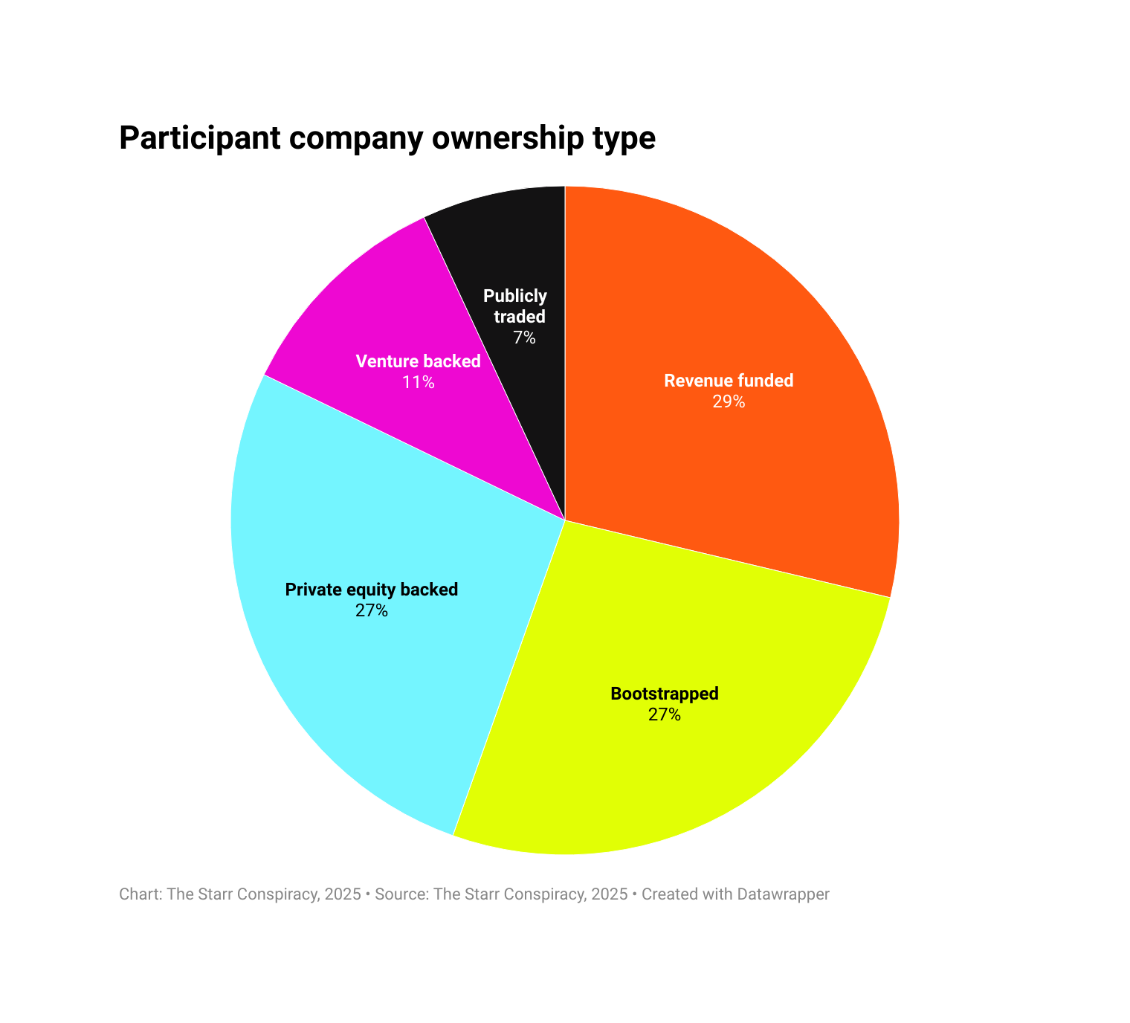
After screening, 307 qualified participants were included in the analysis. Participants represented a balanced cross-section of company funding and ownership models—approximately 29% revenue-funded, 27% private equity-supported, 26% bootstrapped, 11% venture-backed, and 7% publicly traded.
Demographically, the study reflects a mature and experienced cohort: 91% of participants were over 35 years old, with 66% aged 45 or older.

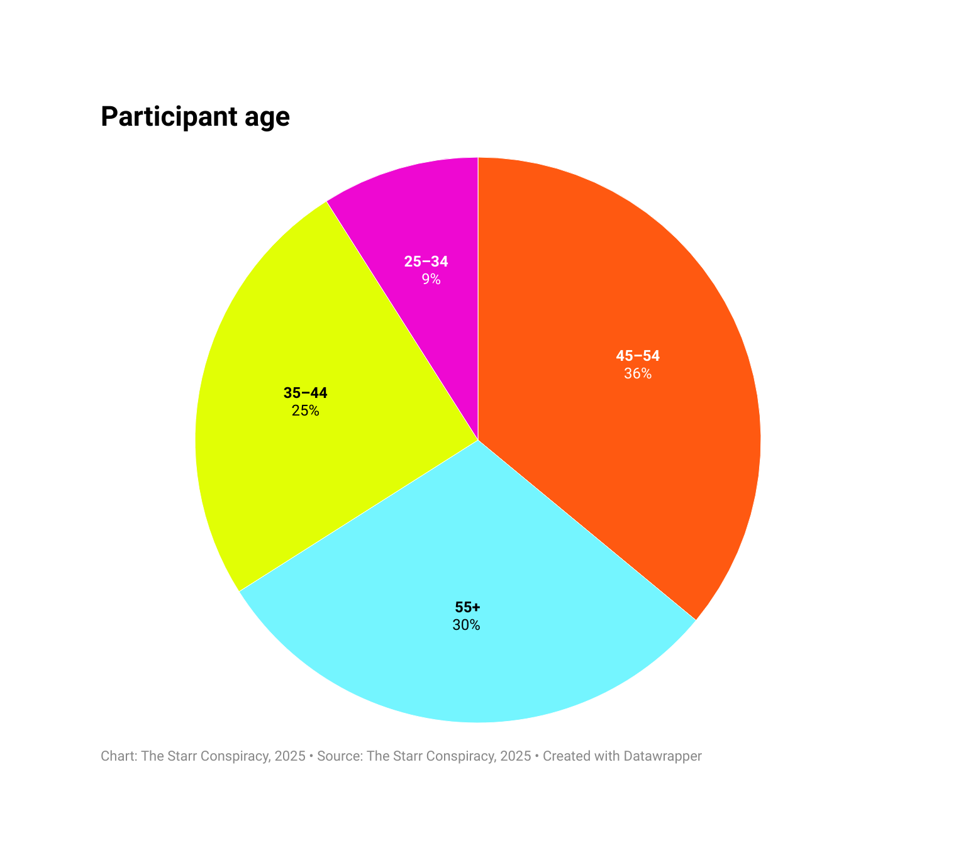

Roles and representation
To ensure insight depth, the study emphasized senior decision-makers:
- 62% held marketing executive roles (VP, CMO, Head of Marketing)
- 11% were marketing team leaders or practitioners
- 16% were in executive management (CEO, COO, CFO)
- 7% served at the board level
- 4% represented adjacent functions with operational insight into marketing (sales, RevOps, etc.)
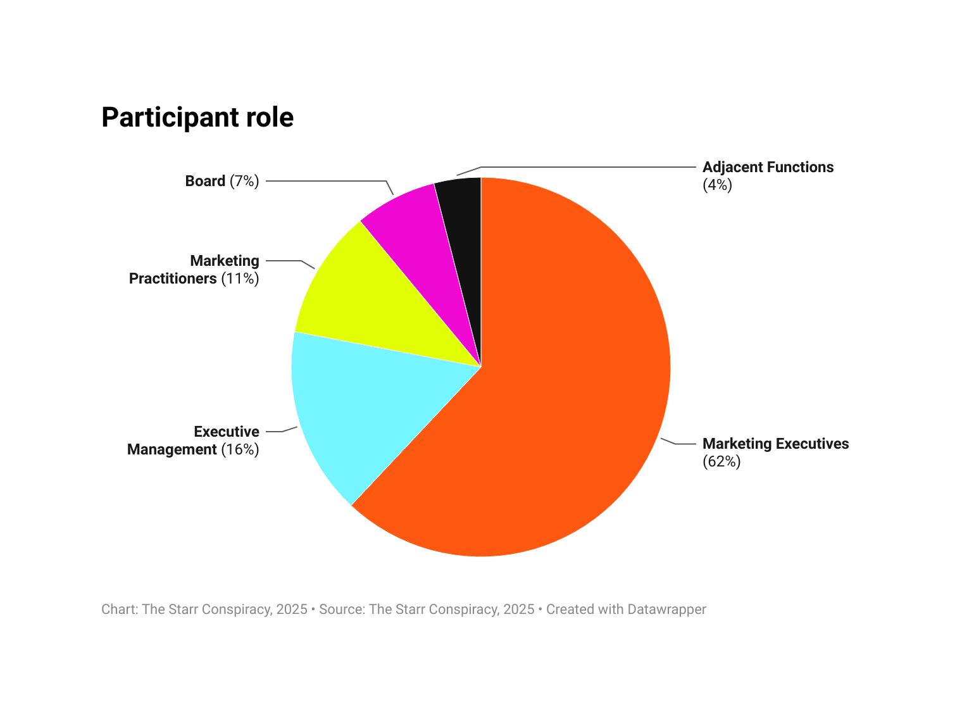

AI-enhanced methodology
The survey incorporated AI-driven dynamic follow-up questions that adapted in real time to participant responses. (Yes, we used AI to ask people about using AI. Very meta. Meta?) These AI-generated “clarify” questions expanded qualitative depth; surfacing beliefs, rationales, and attitudes that would typically require separate interviews. This approach increased the diversity, nuance, and interpretive value of open-ended responses while maintaining response efficiency.
In addition to survey data, the research team:
- Conducted more than two dozen field interviews with senior marketing and growth leaders across B2B technology sectors.
- Applied AI-assisted correlation analysis to align primary findings with recent and relevant secondary research, ensuring that the insights reflect the most current market conditions and industry discourse.

Analytical framework
All data (quantitative and qualitative) was processed through a hybrid framework combining statistical analysis, natural language processing, and qualitative coding. AI systems were used to:
- Detect emergent patterns and correlations across response groups
- Identify outliers and statistically significant relationships
- Thematically code open-text responses for sentiment, tone, and thematic density

Integrity and inclusion
Participants were anonymized, and participation was voluntary. AI systems were used to augment, not replace, human analysis, ensuring interpretive judgment remained grounded in human expertise.

Appendix A: Heightened challenges for marketers in private equity-backed companies

Why PE-backed companies lead in marketing vision but lag in marketing innovation

Private equity-backed companies have a big problem. They often employ some of the world's most forward-thinking marketing leaders, yet their organizations systematically lag behind competitors in AI adoption, GTM execution, and technological readiness. This disconnect reveals how PE's operational model (designed to optimize short-term profitability) inadvertently creates structural barriers that prevent even the most progressive marketing talent from translating vision into reality.
The data paints a revealing picture. Marketing leaders at PE-backed companies describe AI as transformational and report using AI tools daily, personally building custom GPTs, and closely following emerging technologies. Yet these same organizations consistently rate their AI readiness as only developing or exploring. Not a single participant from this cohort ever described their AI readiness as operationalizing or fully implemented. (Though presumably they all have dedicated budget for cost-cutting consultants.) By contrast, venture-backed companies, which spend 58-100% more on marketing than their PE counterparts, report higher organizational readiness, dedicated AI roles, and substantive leadership support for technology initiatives.

This gap stems directly from PE's fundamental value creation approach. Research from Harvard Business School confirms that while 95% of PE firms plan to increase AI investments, only a fraction are exploring meaningful use cases, with most reservations emanating from "limited adoption rates" and resource constraints. The traditional PE toolkit (which prioritizes leanness, cost optimization, and financial discipline) actively discourages the long-horizon, uncertain technology investments required for genuine AI transformation. As one study notes, "digital transformation requires organizational change and upfront costs that may not align with PE investors' typical holding periods".
The consequences manifest throughout PE portfolio companies. Despite marketing leaders' enthusiasm, 80% report that AI is either not officially assigned or shared across teams with no dedicated role. They cite recurring barriers: insufficient internal talent, absence of standardized processes, resource constraints, and critically, "lack of time or guidance from leadership". Their comments reveal frustration with organizational inertia. They talk about being actively discouraged from “spending time on science experiments” and struggling to secure company-wide guidelines.
The so-called efficiency trap compounds these challenges. By treating innovation costs as purely operational expenses, PE firms risk "compromised product-market fit, reduced innovation capacity, and lack of adaptability". Portfolio companies operate with intentionally lean teams that manage everything from lead generation to investor presentations (and even organizing company parties).

This dynamic often results in a patchwork tech stack with fragmented CRMs, legacy websites, spreadsheets replacing automation platforms, and inconsistent analytics that stall scalability and undermine confidence in reporting. The infrastructure, data standardization, and talent needed for AI marketing initiatives remain perpetually out of reach for portfolio companies operating under hold period constraints. Ironically, these are the very teams and companies that AI may help the most! (The do-more-with-less crowd who've been doing more with less for so long that less is now just a theoretical concept.)
The outcome is predictable: PE-funded companies experience measurably worse marketing performance, with lead conversion rates 10 points lower than VC-funded competitors at every funnel stage. Despite having marketing leaders with exceptional personal conviction about AI's potential, PE-backed organizations remain structurally incapable of providing the investment, support, or resources necessary to operationalize that vision. This moment stands as a clear demonstration of how private equity's cost-optimization imperatives create a widening innovation gap that even world-class marketing talent cannot overcome. The stakes are highest during periods of transformational disruption. And, for the record, this is a test that private equity-backed technology companies have not had to take before. Because the last time there was disruption of this scale, very few tech companies were owned by PE. That’s more of a recent 21st-century kinda thing.

Appendix B: A repeat of the SaaS revolution
The outcome for companies falling behind is predictable. We've witnessed this transformation dynamic before! While PE-backed companies face the most acute challenges, our research reveals marketing leaders across all funding types struggling with AI adoption, including bootstrapped, revenue-funded, publicly traded, and even venture-backed companies. The difference is merely one of degree, not kind. What awaits these laggards isn't speculation. There is recent historical precedent.
Between 1999 and 2015, B2B tech underwent a comparable transformation when SaaS-based technologies displaced the on-premise era's methodologies. To use examples that speak to marketers, the emergence of Salesforce, Marketo, HubSpot, and Pardot did more than just introduce new tools. These technologies fundamentally redefined competitive advantage in B2B marketing. Companies that failed to adapt to the new performance optimization era weren't merely disadvantaged … many ceased to exist.
The casualties were stark and instructive. Siebel Systems, which controlled more than half of the CRM market in 2002, was obliterated by Salesforce's cloud-first approach. By 2005, Siebel was acquired by Oracle in what amounted to a rescue operation. Similarly, other on-premise marketing automation leaders were systematically displaced by cloud-native competitors that could iterate faster, deploy instantly, and scale elastically. These weren't gradual market share shifts. They were market extinctions.
The pattern was consistent. Incumbents dismissed the new technologies as insufficient for "enterprise needs." They clung to perpetual licensing models while SaaS vendors introduced subscription pricing that lowered adoption barriers. They maintained complex on-premise installations requiring months of IT involvement while competitors offered self-service provisioning and instant deployment. Most critically, they preserved rigid product development cycles while SaaS companies deployed continuous improvements and new features.
The companies that thrived weren't necessarily the largest or best-capitalized. They were the most adaptable. Marketing automation adoption skyrocketed—from just 6% of enterprise software revenues in 2010 to 75% by 2018, a 12.5x increase in market penetration in under a decade. The consolidated value grew from $9.2 billion to over $380 billion. Firms that adopted early experienced demonstrable advantages: 14.5% increases in sales productivity, 12.2% reductions in marketing overhead, and 5.44x ROI on marketing automation investments.
The transformation wasn't limited to technology adoption—it redefined GTM execution entirely. The MQL/SQL qualification framework, lead scoring algorithms, drip campaigns, and account-based marketing strategies all emerged from SaaS-enabled capabilities. Companies without these capabilities couldn't compete. Their manual processes, disconnected data, and inability to operate at digital velocity rendered them obsolete.
Today's AI transformation mirrors this dynamic with eerie precision. Just as SaaS displaced on-premise through superior scalability and velocity, AI is displacing SaaS-era performance marketing through superior intelligence and automation. The SaaS model itself—with its seat-based pricing, tool proliferation, and human-intensive workflows—is being questioned as AI agents promise to deliver outcomes rather than access. Companies still optimizing 2015's playbook while competitors deploy autonomous agents, real-time personalization, and AI-driven content generation face the same fate as Siebel and countless others who dismissed the last paradigm shift.
The lesson is unambiguous: transformational technology moments don't reward caution. They punish it. The companies that treated SaaS adoption as optional—that waited for "proven ROI" or delayed investment until budgets improved—didn't just fall behind. They disappeared. Marketing leaders who recognize this pattern understand that today's AI execution gap isn't a temporary challenge to manage. It's an extinction-level event to survive. Ask an older marketer (hint: if you don’t know their age, they probably love bands like Nirvana, The Breeders, and Jane’s Addiction).

